Preparing (digital) Artwork for Submission

June 2020

For the purposes of this guide, artwork is defined as all non-textual two-dimensional visual content including but not limited to, figures, maps, drawings, sketches, graphs, paintings, illustrations and photographs. Time based media is defined as audio and video content.

INTELLECTUAL RIGHTS
Design Arts Culture (DAC) considers all submitted artwork on the condition author(s) confirm that third-party intellectual property rights are not violated in any way.
Author(s) are responsible for securing permissions to publish copyrighted material, such as photographs and other artwork and for paying any fees involved. Production of an article will not begin until the editor has received all relevant permissions.
The copyright for published articles in DAC is retained by the author(s). By virtue of their appearance in this open access journal, articles can be used freely, with proper attribution, for educational and other non-commercial purposes.

ARTWORK SPECIFICATIONS
Digital artwork could be either raster images (bitmap graphics) produced with a scanner or captured with a digital camera, or vector images (vector graphics) created with vector editing software or a combination of both (combination artwork). To ensure best quality reproduction digital images must have enough pixel count (resolution) to accommodate scaling to the required print size and saved to the recommended file format. Vector graphics are resolution independent and are rasterized at the required print resolution when imported to the page layout program.

Size and Resolution
Submitted raster images horizontal (width) dimension should be no less than 20 cm (approx. 8 inches) at a set resolution of 300 ppi (pixels per inch) which equals to an image width pixel count of 2360 pixels; height will be determined by the aspect ratio of the source image. This means your digital image must have a minimum width pixel resolution of 2360 pixels.
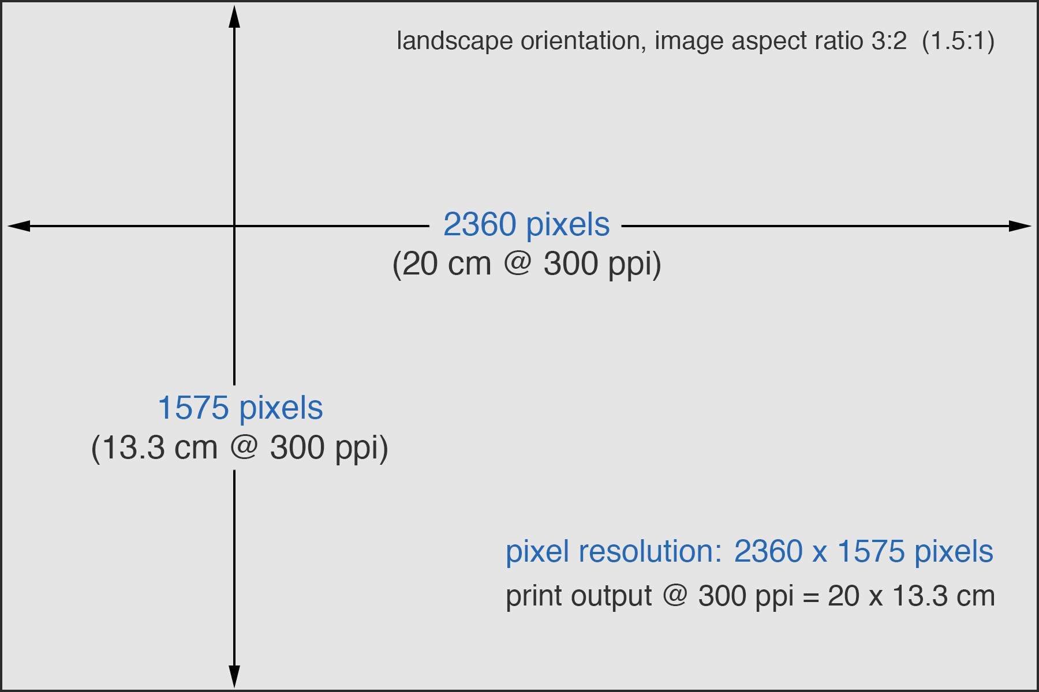
Figure 1. A digital raster image with aspect ratio 3:2 and pixel resolution 2360 x 1575 pixels when printed at 300 pixels per inch (output resolution) will produce a 20 x 13,3 cm (7.9 x 5.3 in) print.

Color Mode, Bit Depth and Color Space
Raster images should be encoded in RGB color mode with a bit depth of 8-bits per color channel (24-bits per pixel) and in sRGB color space. When saving your final images ensure sRGB color profile is embedded in the image.
If you are submitting existing digital images with no color information already encoded in Grayscale color mode you do not need to convert to RGB color mode and can submit as is.

File Formats
Recommended file formats for artwork and time based media.

Format | Extension | Details
TIFF  (Tagged Image  File Format) | .TIF  .TIFF | Preferred file format for raster images of line art, monochrome images and photographs (grayscale or color)  - Image should be in RGB color mode  - Bit depth should be 8-bits/channel (24-bits/pixel)  - Image should be in sRGB color space  - Image data should be on one single background layer (flattened) with no extra data like layers, alpha channels, type layers, masks etc.
JPEG  (Joint Photographic  Experts Group) | .JPG .JPEG | Acceptable file format for raster images (photographs).  - Image must be in RGB color mode  - Image should be saved at "maximum quality" setting  - Image should be in sRGB color space
EPS  (Encapsulated PostScript) | .EPS | Preferred file format for vector only images (vector line art, graphs, charts, technical drawings etc.) or a combination of raster and vector graphics.
PDF  (Portable Document Format) | .PDF | Acceptable file format for raster images, vector graphics or a combination of both.
MP3 | .MP3 | Preferred format for audio content Audio bit rate at least 256 kbps
MP4 | .mp4 | Preferred format for video content  - Frame rate: 25 frames per second (minimum)  - Video codec: H.264  - Audio codec: AAC  - Video bit rate: at least 10 Mbps  - Resolution: Full HD 1080p (1920x1080 pixels)
M4V | .m4v | Acceptable video format
QuickTime  (Quick Time File Format) | .mov | Acceptable video format
(*) When submitting video content you must also submit an image file (a selected movie frame) to be used as a still preview of the movie on the printed journal.

File Naming
Please name artwork files as "Figure 1, 2, 3..." according to the order they appear in your manuscript text. Always use a consistent scheme for all files, like:

Figure_01.tif | Figure-01.tif |  | Fig(01).tif
Figure .... | Figure .... |  | Fig ....
Figure_09.eps | Figure-09.eps |  | Fig(09).ep
Figure_10.pdf | Figure-10.pdf |  | Fig(10).pdf

(*) For proper format identification ensure file extension is always included in the file name.

Captions
Ensure that each image has a caption. A caption should comprise a brief title and a short description. If the image is not the property of the author(s) or has been previously published ensure that the necessary credit line or acknowledgments are included. Captions should be submitted separately as text in a text file, not embeded in the image.

3D Objects
We encourage the submission of 3D objects (models) that can be viewed interactively from within a PDF document.
- 3D artwork should be submitted only in U3D (Universal 3D) format.
- Author(s) should embed U3D files into a single blank PDF page before submission.
- Author(s) will also need to supply a flat image only version of each digital object to be used for the print version of the article.

Important note: Embedded 3D images will function correctly when the PDF document is opened with Adobe Acrobat. If the reader opens the PDF directly within a web browser, like Internet Explorer or Chrome, the interactive elements may not function correctly.
(*) more on displaying 3D models can be found here: https://helpx.adobe.com/acrobat/using/displaying-3d-models-pdfs.html

